Set project ID and enable the services
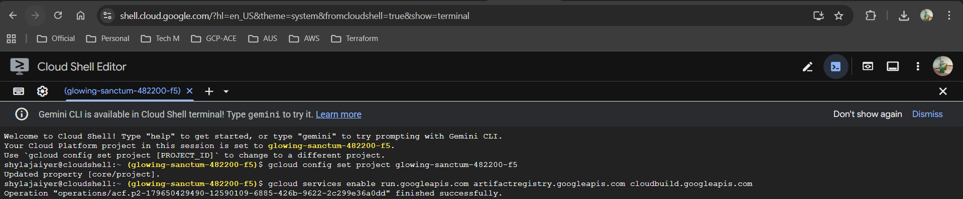
Setup artifact registry to store the image of the application
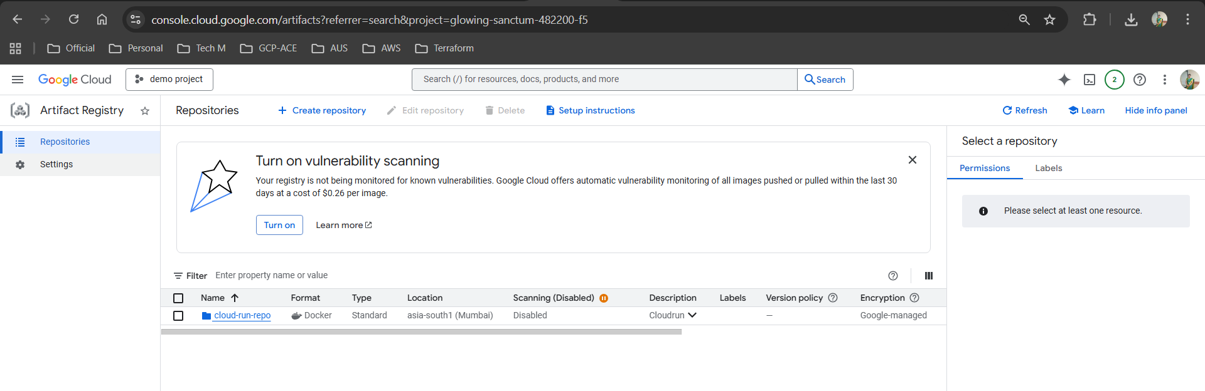
Authorize the docker packages in that location
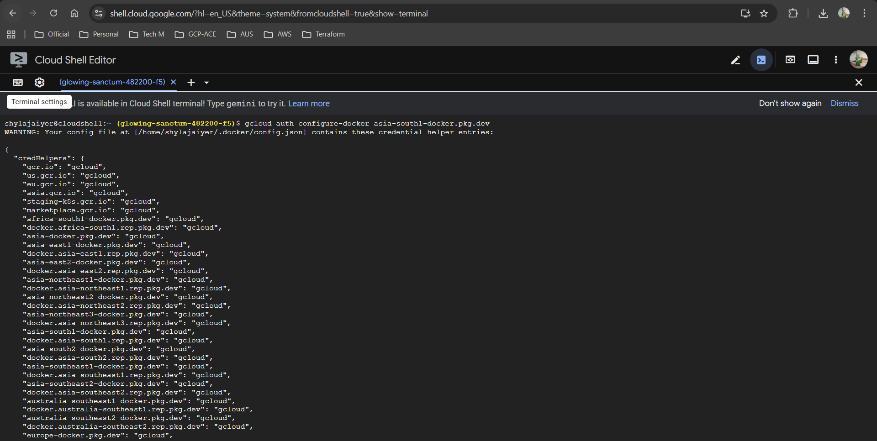
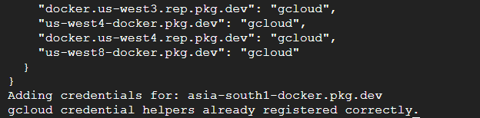
Building Docker image in cloudshell by running maven cmd
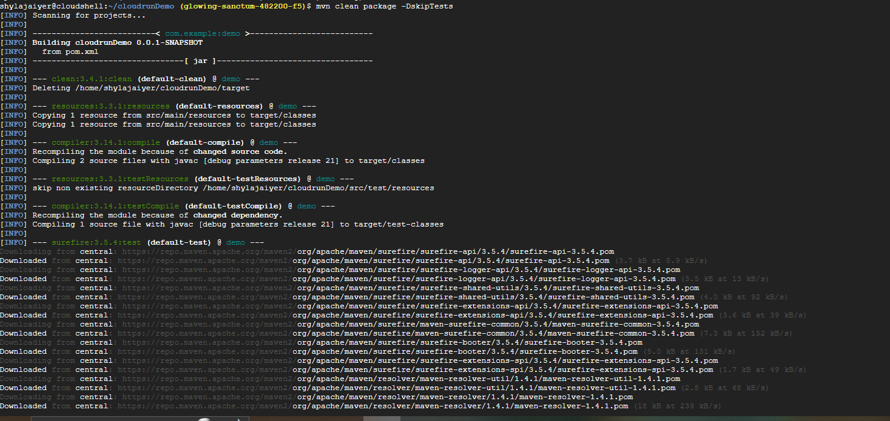
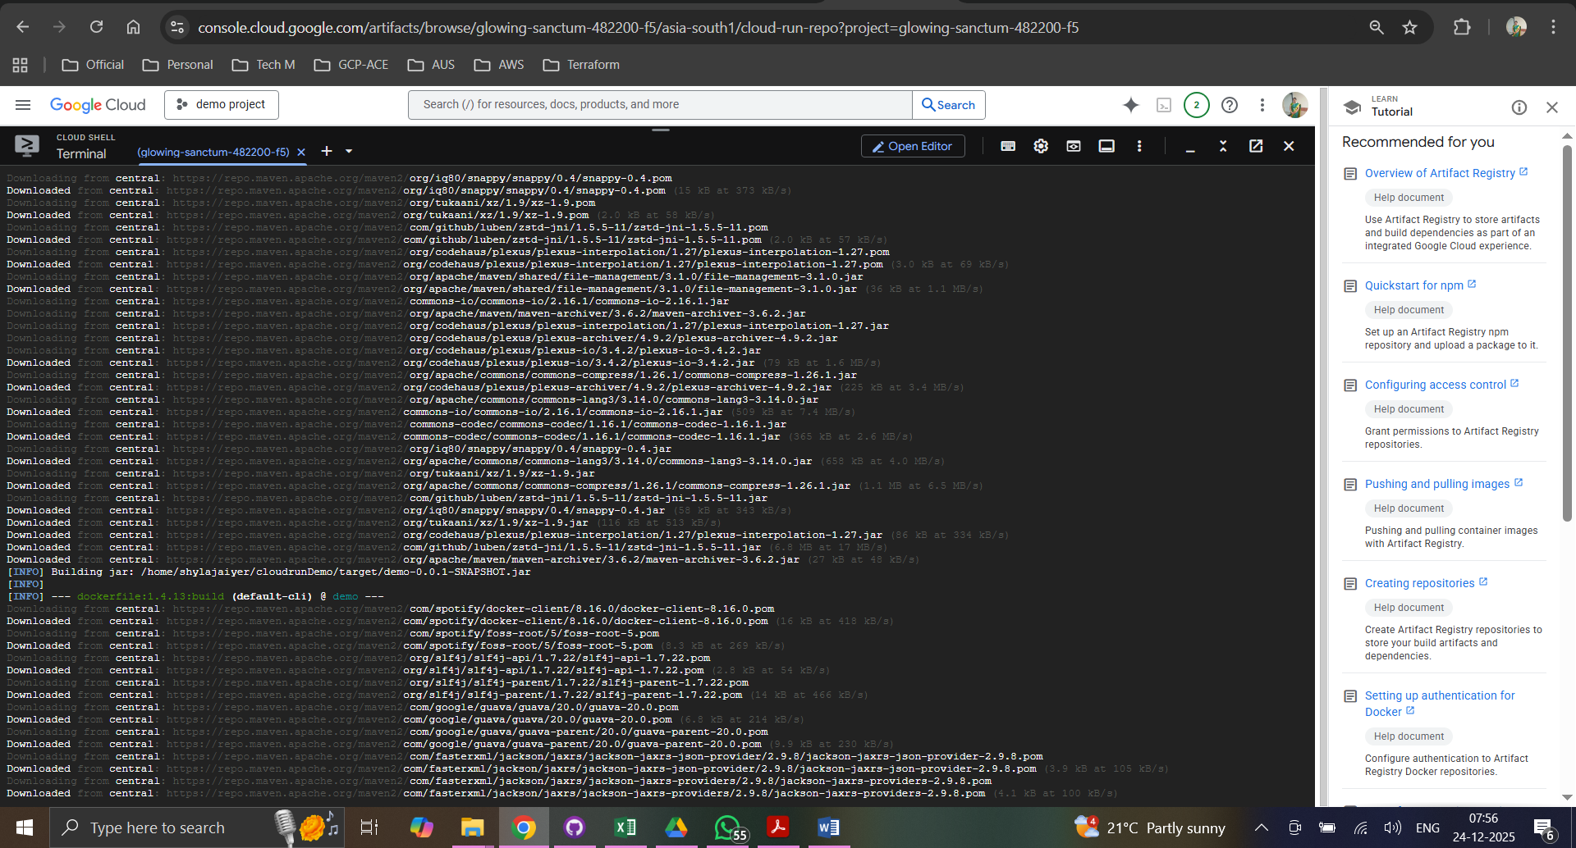
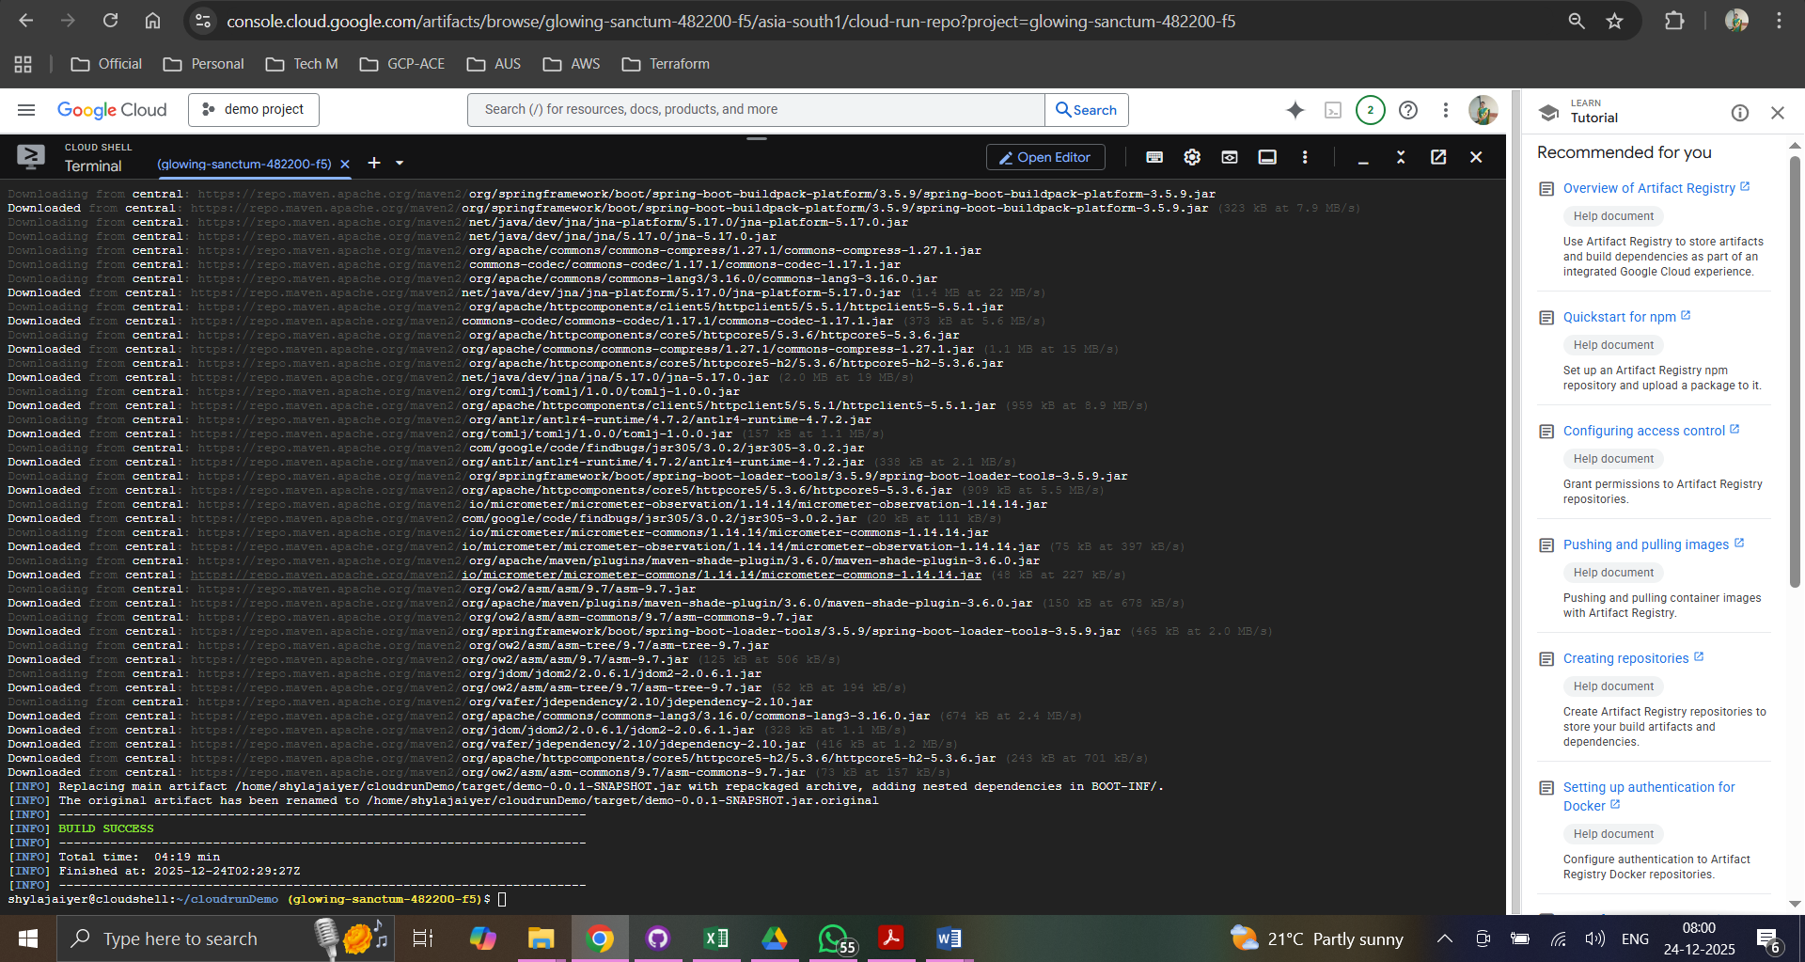
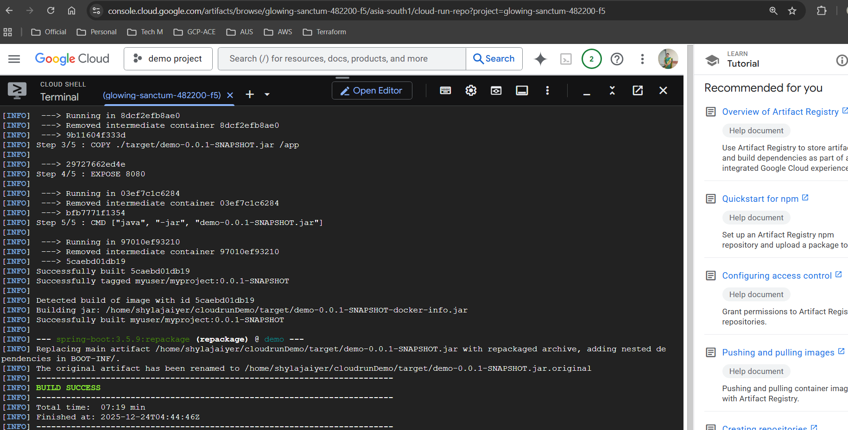
Image created
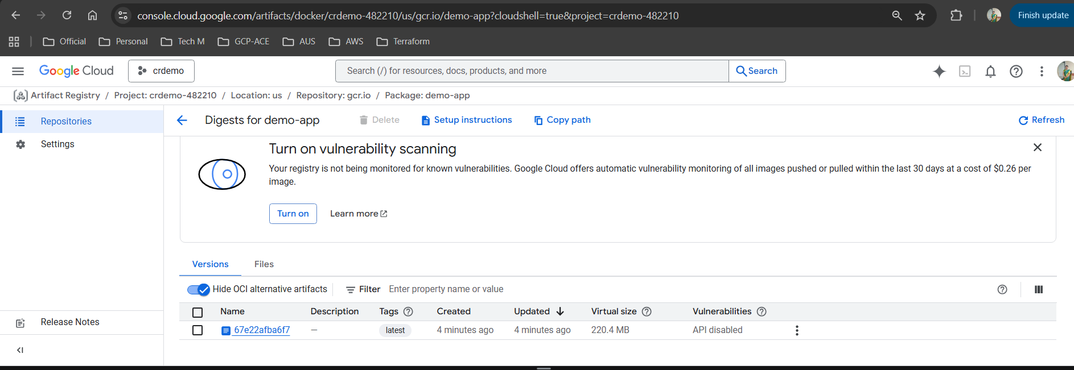
Deployment
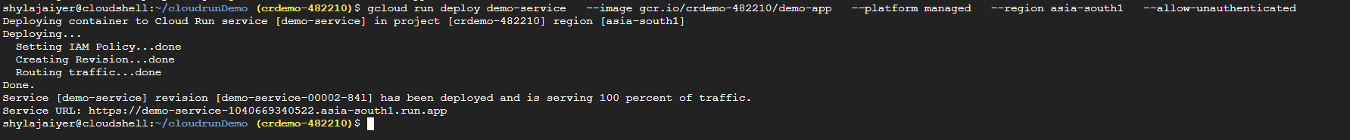

App is available now !!!
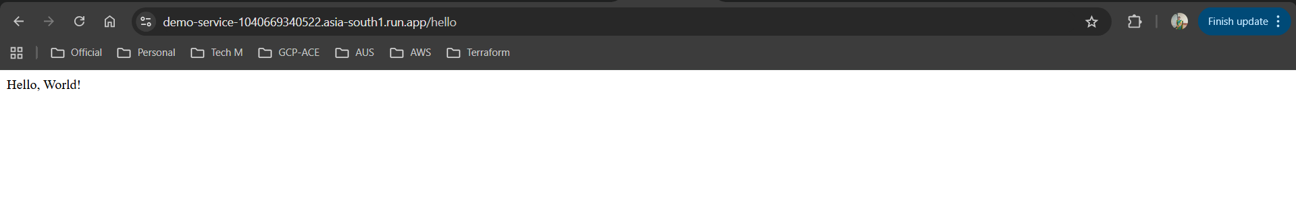

Delete Cloudrun Service
Delete the Image in GCR
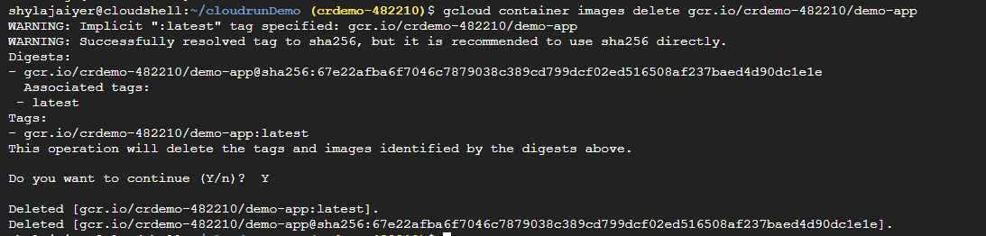

Removing the images from cloud storage
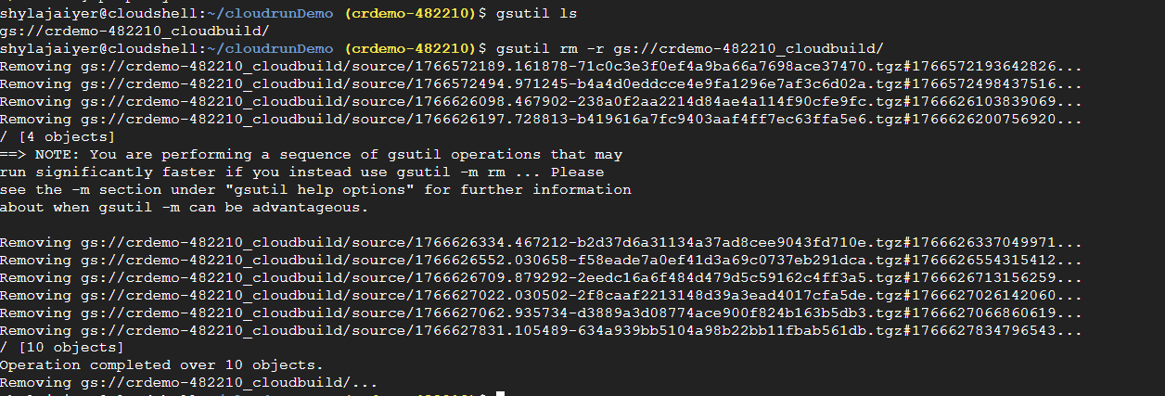

Delete project
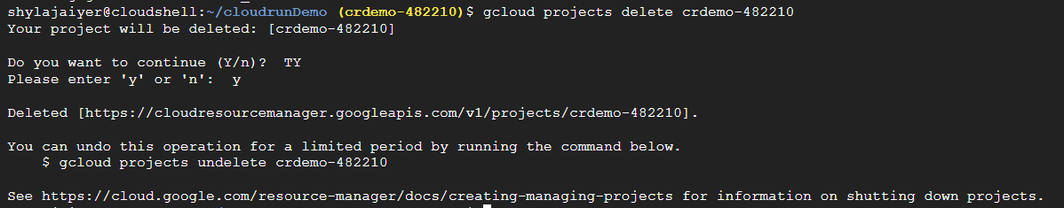

To confirm the same

